Fake Currency Recognition Using Image Processing

Mukesh Patel School of Technology Management and Engineering, SVKM’s NMIMS, Mumbai.

1st Shaun Wadhwana – L041

shaun.wadhwana003@nmims.in

2nd Shiv Tandel – L043

shiv.tandel011@nmims.in

3rd Yuvraj Shah – L062

yuvraj.shah002@nmims.in

4th  Zahan Dastur – L063

zahan.dastur007@nmims.in

***Abstract*—Fake money circulation is a big problem that affects both regular people and our country’s economy. Even though there are machines that can spot fake money, they are only in banks and big offices, leaving regular people and small businesses at risk. So, in this project, we will investigate the various security features of Indian currency and then, prepare a software- based system to detect and invalidate fake Indian currency by utilizing various parts of Digital Image handling, such as image acquisition, gray scale conversion, Image Segmentation, feature extraction. This program will use advanced techniques to find and stop fake Indian money by analyzing images.**

***Index Terms*—Fake currency, counterfeit detection, image processing, feature extraction, image segmentation, gray scale conversion**

1. Introduction

Counterfeiting involves the unauthorized replication of com- modities, particularly currency, with the intention of personal gain. Counterfeit currency resembles genuine notes but lacks governmental approval. Thus, it is a vulnerable threat on the economy and it enhances inflation.

According to a survey conducted, 6,32,000 fake notes were discovered in the year 2015-2016. The number took a jump of 20% by the end of 2017 summing to a total of 7,64,072 fake notes [ref]. To overcome this issue, there is an urgent need for a system that could easily be implemented and provide an accurate method for counterfeit notes detection. Fig.1 illustrates the various statistics associated with the detection of counterfeit banknotes.

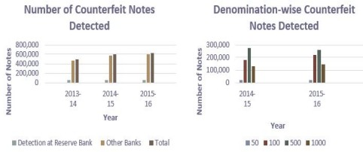

Fig. 1. Statistics on detected counterfeit banknotes

Different methods have been created to find fake money by looking at certain features of the money. These methods include using infrared light, checking for features under UV light, and using properties of light like polarization and graphic

techniques. Another way is to do a chemical analysis of the paper used to make the money and manually inspect- ing the notes. However, the current solutions are either too complicated, require special equipment, are costly, or are not easily available to the common person. Therefore, we need an automated way to detect fake money that is accurate and provides quick results. Hence we propose a cost-effective and robust automated counterfeit currency detection tool using image processing techniques which could be deployed by common people. The proposed system is designed to validate Indian currency notes of denomination 50, 100, 200, 500 and 2000 rupees. The system checks the authenticity of various features in a currency note. It includes several steps including image acquisition, pre-processing, greyscale conversion, feature ex- traction, image segmentation, comparisons of images with the dataset. Finally, the processed output is displayed for each currency note. This system provides a hassle-free way to authenticate currency notes quickly and accurately. This automated system can replace the existing manual methods and can be used by anyone easily to detect fake currency.

The remainder of the paper mentions the following details. In section II, there is brief information on some related papers that are used for reviewing. Section III discusses the problem statement addressed by our proposed model. In section IV, the methodology is mentioned which specifies the different steps used in the entire process of currency detection. While section V covers the details of the proposed system and Section VI shows the result and conclusions. Section VI mentions the referred papers and links.

1. Literature Review

Various papers are available that contain information on Fake currency detection. Some referred papers are mentioned here.

1. This research paper suggests a way to make money detection better in places like banks and shopping malls. It talks about fixing errors or distortions in the pictures of money by using techniques like Radiometric corrections and Geometric corrections. The paper looks at different methods from other studies, compares them, and shares the results, showing how well each method works in terms of accuracy.
2. In this paper, An automatic recognition of fake Indian paper currency note using MATLAB is implemented and

feature extraction with HSV color space and other applica- tions of image processing. The methodology involves distinct stages, including image acquisition, gray-scale conversion, edge detection, image segmentation, characteristic extraction, comparison, and final output. The experimental configuration involves the placement of a currency note in front of a camera to ascertain its authenticity. The clicked pictures of notes are analyzed by MATLAB program installed on the computer. This algorithm works for Indian denomination 50, 100, 200, 500, 1000. If the note is genuine, the respective message is appeared on the screen and vice-versa.

1. This paper proposes a hybrid fake currency detection model implemented on MATLAB. The model was designed to detect fake Bangladeshi notes. In the proposed model, three image processing algorithms were chosen namely Optical Character Recognition(OCR), Hough Transformation and Face recognition(MSD) to get enhanced results. Then, the results of the proposed model were compared with each model used. The algorithm followed six basic steps: data collection, pre- processing of the collected data, edge detection, feature extrac- tion, identification and output results. In addition, although the proposed model took slightly longer to process, it displayed 93.33% accuracy which was significantly higher compared to the individual algorithms applied.
2. In this paper we explore two methods to tell apart fake and real currency. First, we analyze them using hyper- spectral imaging, and second, we extract various features from both types of notes. By comparing these features, we can identify whether a note is genuine or counterfeit. The hyperspectral imaging involves using different colored lights such as Ultraviolet (UV), Normal LED Bulb, Red LED light, Green LED light, and Blue LED light, each with specific wavelengths. These methods are carried out using MATLAB. They created a system for detecting fake notes using image processing algorithms. The experimental results show that the system is quite accurate in distinguishing between real and fake currency.
3. Problem Statement

In recent times, counterfeiting has become a pressing concern faced throughout the world especially affecting the economy of almost every country including India. The problem we aim to address in this project is to test the authenticity of Indian currency notes by preparing a system which takes the image of currency bill as input and gives the final result by applying various image processing and computer vision techniques and algorithms. The key challenge is to develop a model that can effectively differentiate between fake and genuine currency notes based on currency notes security features.

1. The main objective of the project is to identify the fake Indian currency notes through an automated system by using Image processing and computer vision techniques.
2. The system should have high accuracy.
3. The system should be able to give the final results in a short time.
4. The system should have an User-friendly interface, to make it convenient to use and understand.
5. Proposed Methodology

Our proposed methodology for fake currency detection centers on image processing techniques such as grayscale conversion, edge detection, segmentation, etc. which are performed using suitable methods[fig2]. The system is designed completely using MATLAB. Figure 2 shows the flowchart that shows the general methods used to detect fake currency using image processing. Figure 3 shows the architecture diagram

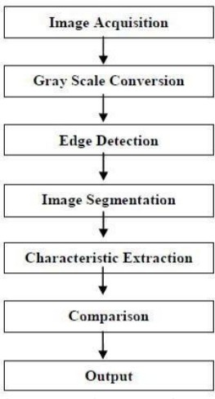

Fig. 2. Flowchart of fake currency detection

for the proposed system in which the input is a photographed or scanned image that is given to the system which can be of .png/.jpeg or any other image extension file. The image is preprocessed removing undesirable noises using suitable filters. The pre-processed image is converted to gray scale from which edge detection is performed. Thresholding is then used to perform segmentation on image. At last features are extracted from segmented images which are then compared with stored images of dataset and the output tells whether the currency is genuine or not.

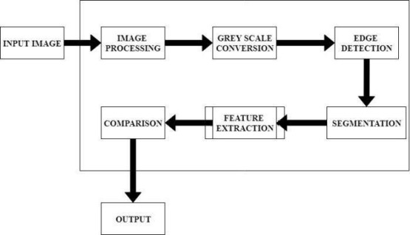

Fig. 3. Architecture diagram of proposed System

1. *About the dataset*

Our dataset contains the following repositories:

* 1. Sub- dataset for Rs. 50 currency notes including images of real notes, fake notes and multiple images of each security feature.
  2. Sub- dataset for Rs. 100 currency notes including images of real notes, fake notes and multiple images of each security feature.
  3. Sub- dataset for Rs. 200 currency notes including images of real notes, fake notes and multiple images of each security feature.
  4. Sub- dataset for Rs. 500 currency notes including images of real notes, fake notes and multiple images of each security feature.
  5. Sub- dataset for Rs. 2000 currency notes including images of real notes, fake notes and multiple images of each security feature.
  6. Images of various security features like Rs. 500 in Devanagari and English script (2 features),Ashoka pillar Emblem (1 feature),RBI symbols in Hindi and English (2 features),500 rupees written in Hindi (1 feature),RBI logo (1 feature),Bleed Lines on Left and right side (2 features),Number Panel (1 feature),

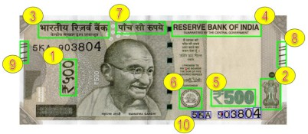

Fig. 4. Security features in currency bill

1. *Image Acquisition and Preprocessing*

The system begins by acquiring a digital image of the currency note through a graphical user interface that supports standard formats such as JPEG, PNG, and BMP. The input image is then converted into grayscale for texture and edge-based analyses, while an HSV (Hue, Saturation, Value) transformation is applied for color-based feature detection. To enhance visibility in poorly illuminated regions, Contrast-Limited Adaptive Histogram Equalization (CLAHE) is employed, ensuring that critical security features are preserved for further processing.

1. *Security Thread Detection*

A key security feature of Indian currency is the embedded metallic security thread. The system detects this by analyzing the HSV color space to identify silver-colored regions. Morphological operations are applied to isolate continuous vertical lines, and aspect ratio filtering ensures the detected region matches the thread’s expected dimensions. If a valid thread is found, a bounding box is overlaid on the image for visual confirmation, and a high detection score is assigned.

1. *Watermark Verification*

The watermark, typically a faint image of Mahatma Gandhi, is extracted using Discrete Wavelet Transform (DWT) to separate low-frequency components. Adaptive thresholding isolates the watermark region, followed by a Viola-Jones face detection algorithm to verify the presence of Gandhi’s portrait. If the face is detected, the watermark is considered genuine, contributing significantly to the overall authenticity score.

1. *Latent Image Examination*

Image Latent images, such as the denomination numeral visible when the note is tilted, are detected using Sobel edge detection. Morphological filtering removes noise, and connected component analysis identifies numeral-like structures. A high edge density in the expected region confirms the presence of a latent image, which is crucial for higher-denomination notes like ₹500 and ₹2000.

1. *Micro-lettering Analysis*

Micro-lettering, consisting of tiny "RBI" and denomination text, is identified using high-sensitivity Canny edge detection. A sliding window calculates edge density, and regions with high textural complexity are classified as micro-lettering. Since counterfeit notes often lack fine details, successful detection strongly indicates authenticity.

1. *Color-Shifting Ink Detections*

For newer currency notes (₹500 and ₹2000), color-shifting ink is analyzed in the HSV space. The hue channel’s variance is measured, and regions with significant color transitions (e.g., green to blue when tilted) are marked. A high variance score confirms genuine ink, while uniform coloration suggests forgery.

1. *Intaglio Printing Verification*

Genuine currency notes use raised intaglio printing, which creates a distinctive texture. The system applies Canny edge detection and computes edge density—higher density indicates genuine intaglio printing, while smoother regions suggest counterfeit notes.

1. *Identification Mark Detection*

A raised identification mark, designed for the visually impaired, is detected using blob analysis. Circular or square shapes with specific aspect ratios are identified, and their presence reinforces authenticity.

1. *Serial Number Validation*

The serial number is extracted using Optical Character Recognition (OCR) and checked for correct formatting (e.g., alphanumeric patterns). If OCR fails, Maximally Stable Extremal Regions (MSER) detect text regions as a fallback. A valid serial number increases the note’s trust score.

1. *Decision Fusion and Final Classification*

Each feature’s detection score is weighted based on importance (e.g., security thread carries 25% weight). The weighted sum generates an overall authenticity score, with values above 0.66 classifying the note as genuine. The system provides visual overlays and a detailed report, ensuring transparency in the decision-making process.`

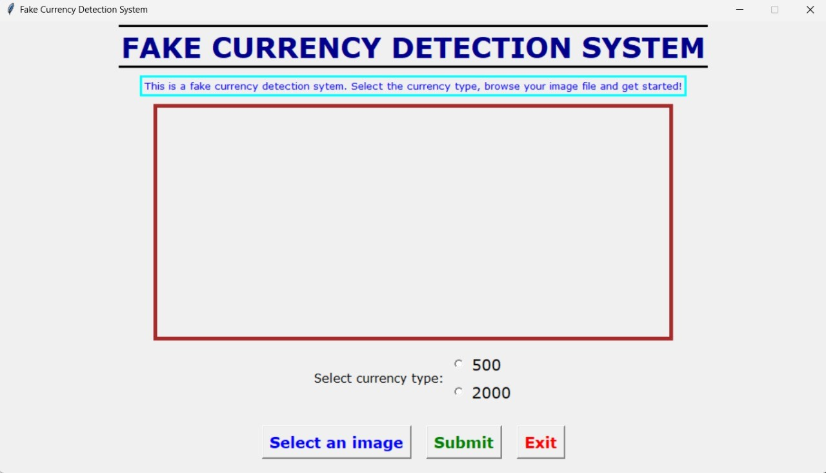

Fig. 5. Initial GUI

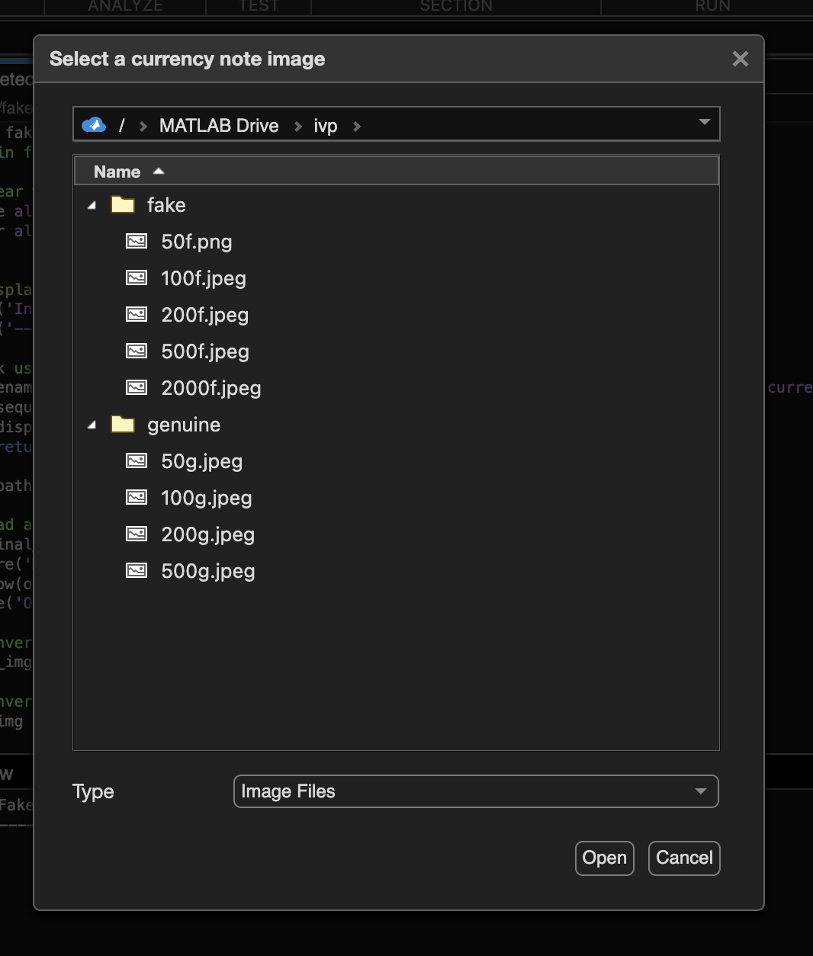

Fig. 6. Browsing image

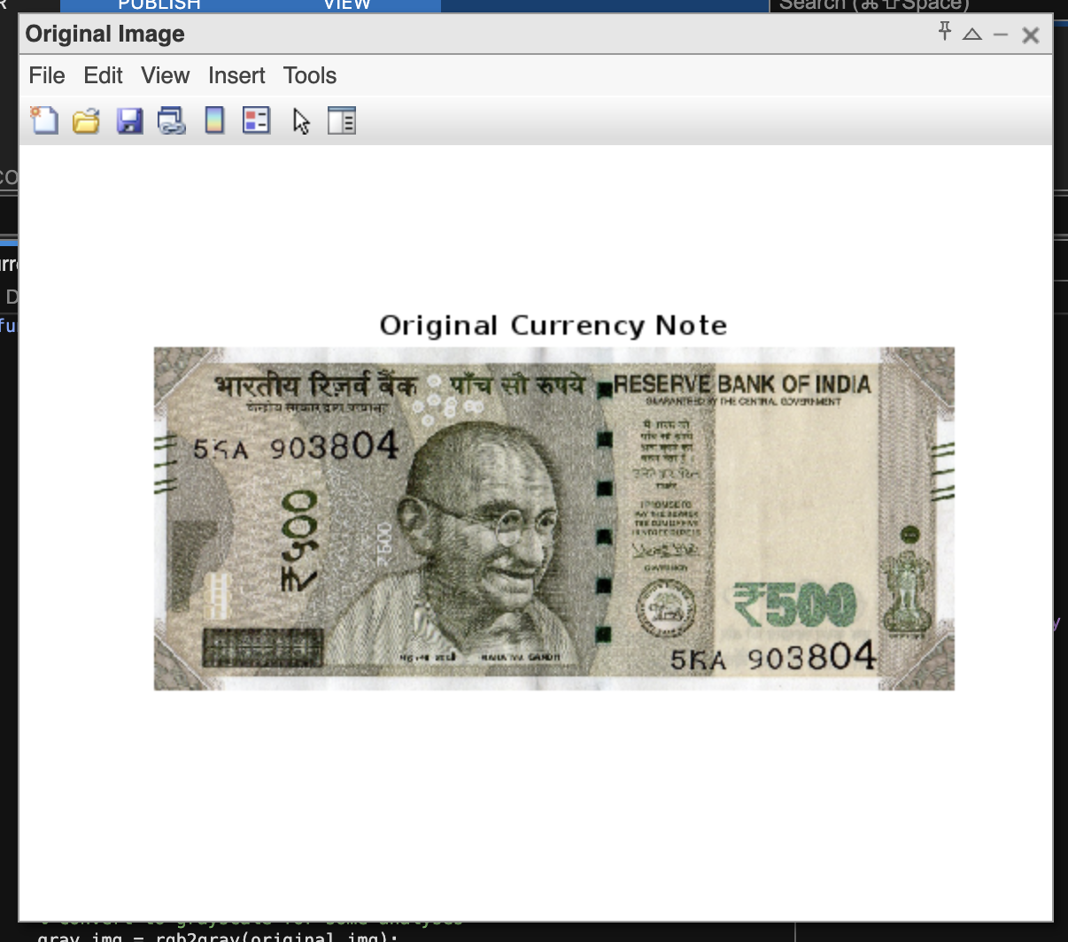

Fig. 7. Gui after input image

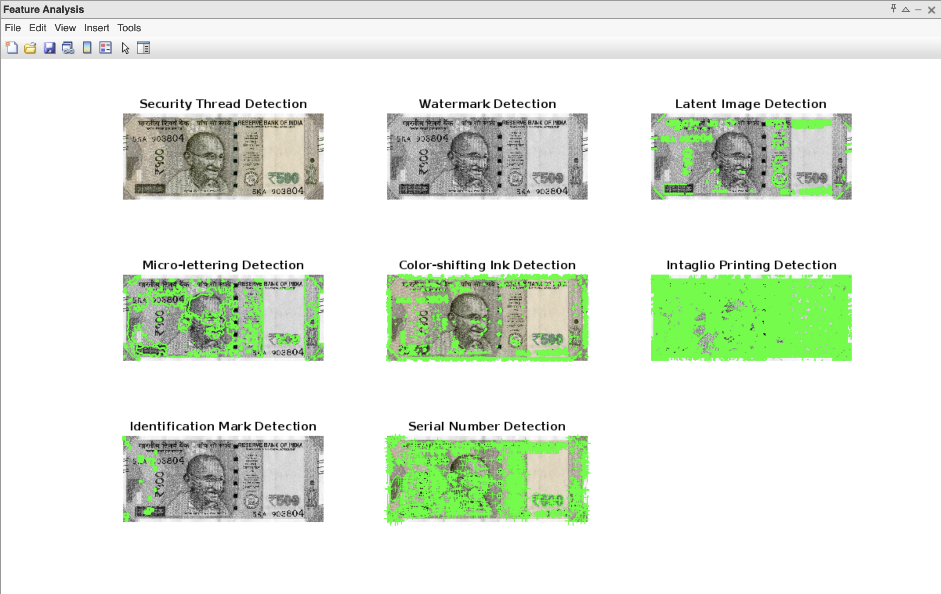

Fig. 8. Feature Analysis

1. *Displaying Output*

Finally, the result of all algorithms is displayed to the user. The extracted image of each feature and the various important

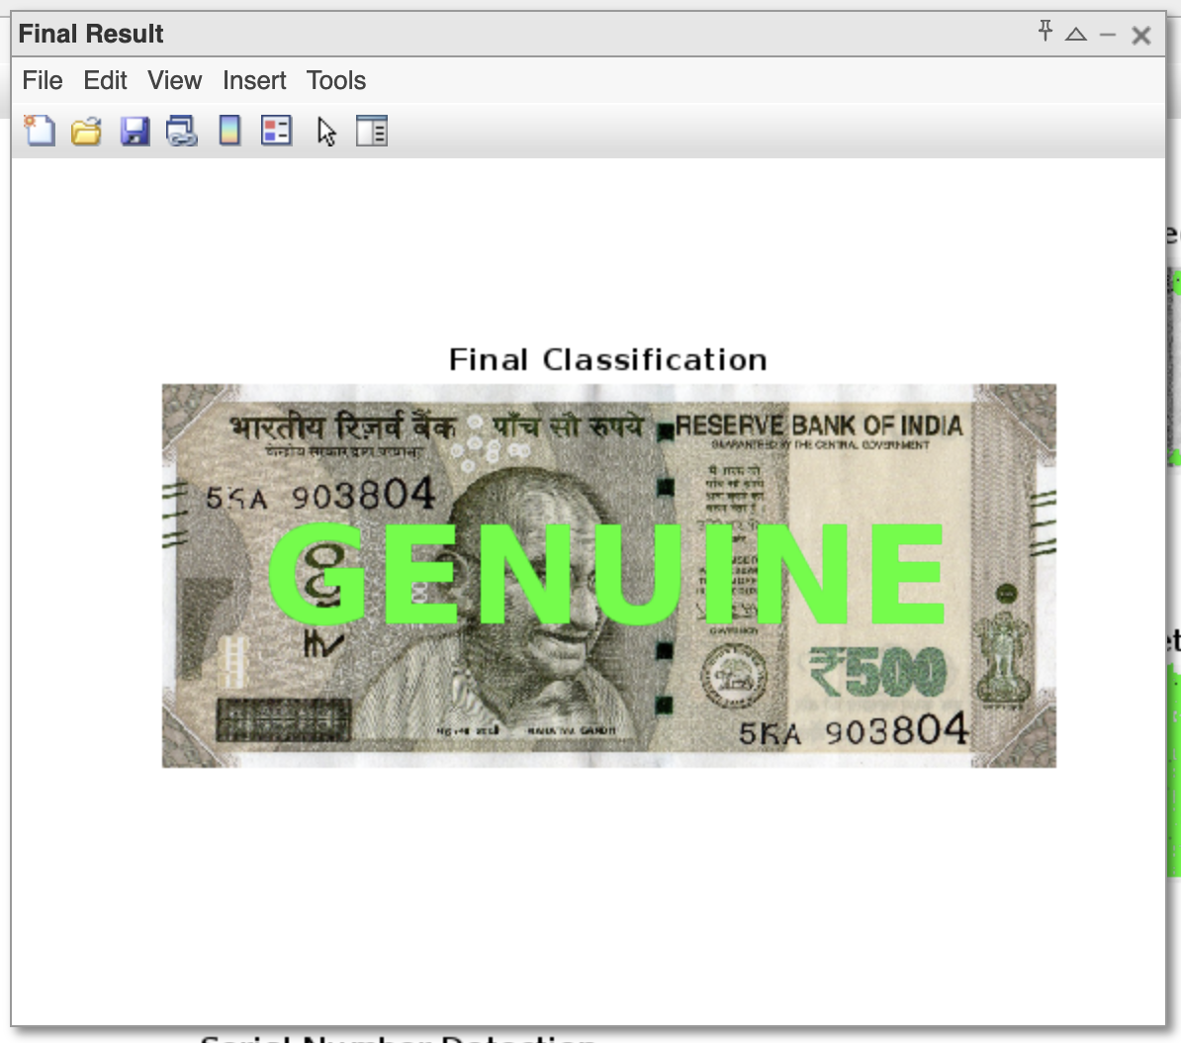

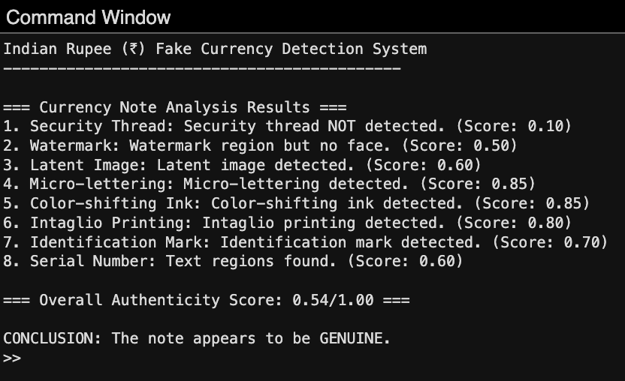

Fig. 10. Output displayed(real note)

data collected for each feature is displayed properly in a GUI window. Further, the status (Pass/ Fail) of each feature is displayed along with the details. Finally, the total number of features that have passed successfully for the input image of currency note is displayed and based upon that it is decided whether the note is fake or not. Fig 10 displays output for a real currency note while fig 11 displays output for a fake currency note.

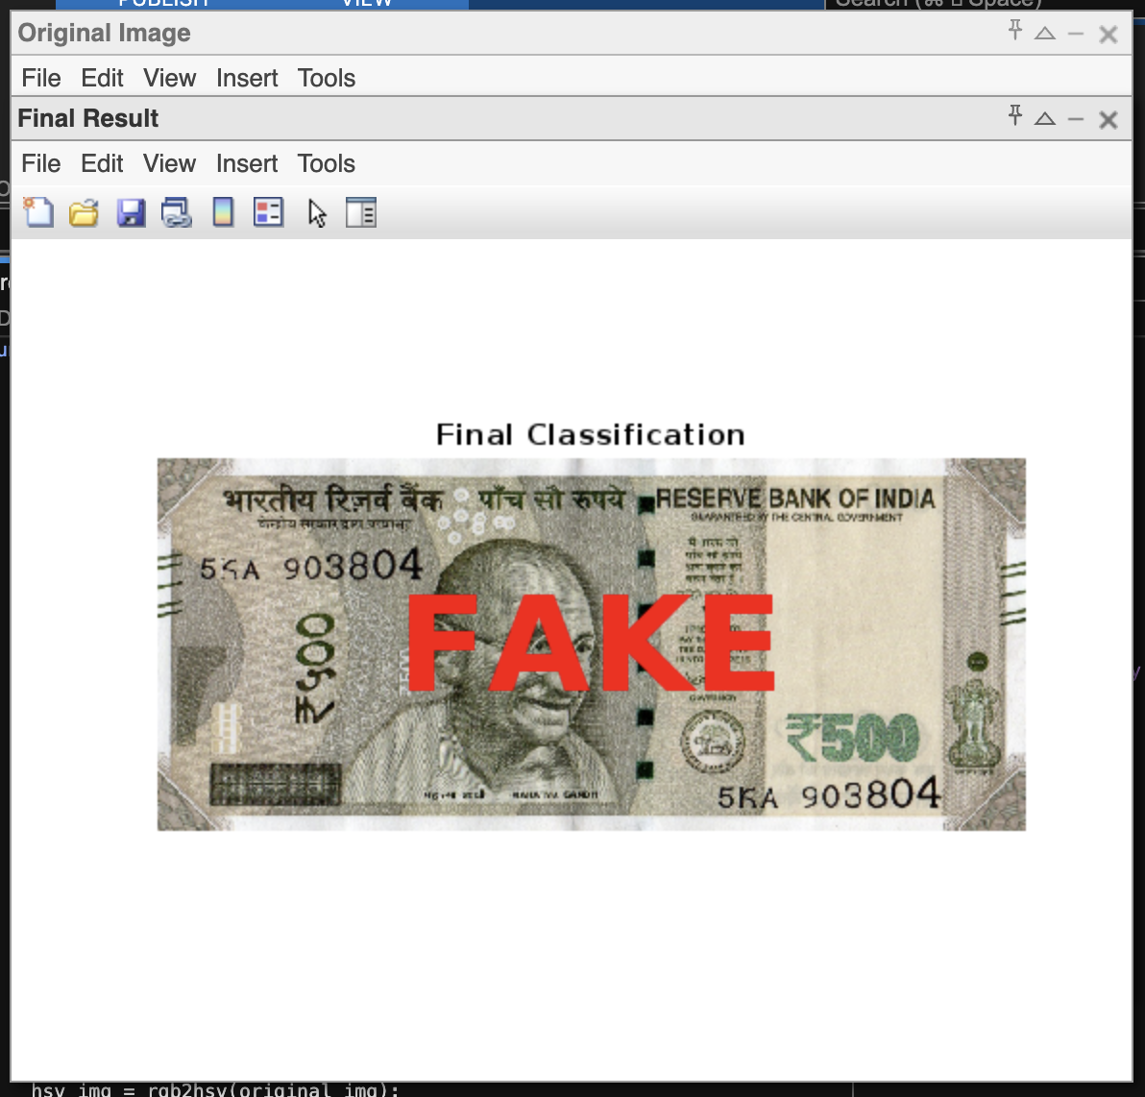

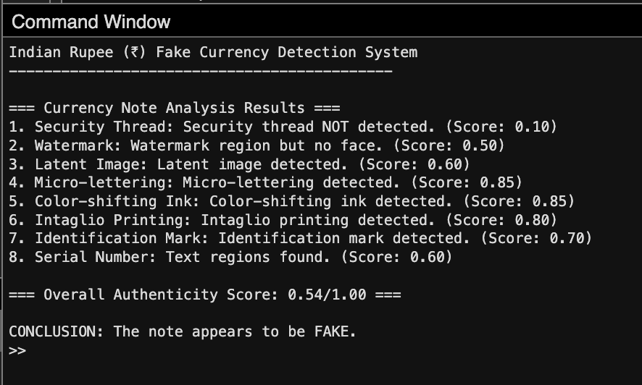

Fig. 11. output displayed(fake note)

1. Results and Analysis

In this paper, a fake currency detection model has been proposed for authentication of Indian currency notes of de- nomination 500 and 2000 and implemented using OpenCV image processing library in Python3. In this model, 10 features of the input currency note are considered and then analyzed in detail. We have performed the experiment for a set of inputs and collectively analyzed the results obtained in two sub sections.

* 1. **Performance Analysis** For the sake of calculating the accuracy, it was assumed that if the currency note passed 66% match, then the note is real otherwise it is fake. Testing of both real and fake notes was done separately. Fig 12 shows the graph of accuracy obtained for both real and fake currency notes.
     1. For testing of real notes, 11 real notes for Rs.2000 and 10 real notes for Rs. 500, 10 real notes of Rs. 200, 10 real notes of Rs. 100 and 9 real notes of Rs. 50 were considered, out

of which 26 of the total 35 notes gave the correct desired results. Accuracy: 74%

* + 1. Similarly, for testing fake notes, 3 fake notes were taken into consideration for each denomination (15 notes in total), for which 12 of the 15 notes gave the correct required output. Accuracy: 80%
  1. **Time Analysis** Along with the final results, a lot of images and other analysis related data is being printed by our system. If all the data is printed, then the system takes about 35 seconds to process, print all the data and give the final results. If only the final results are displayed after processing of input image, the system takes only 5 seconds for each input image. So, practically the model takes about 5 seconds to give the results of each input image.

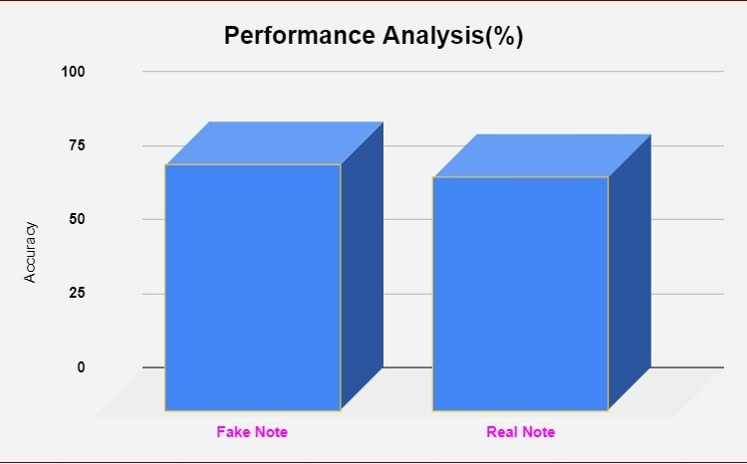

Fig. 12. Performance Analysis Graph

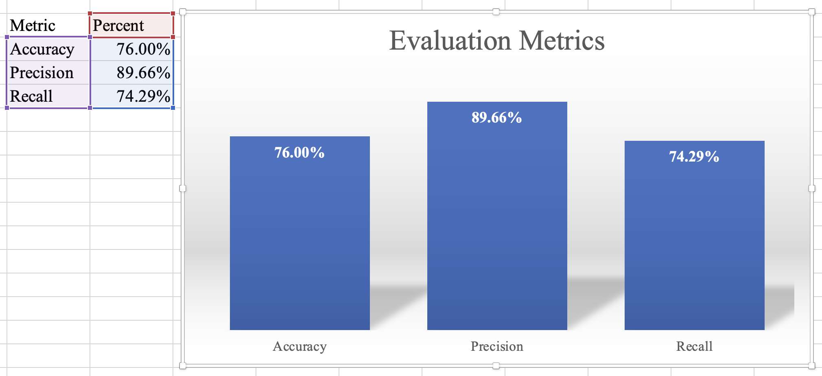

Fig. 13. Evaluation Metrics Graph

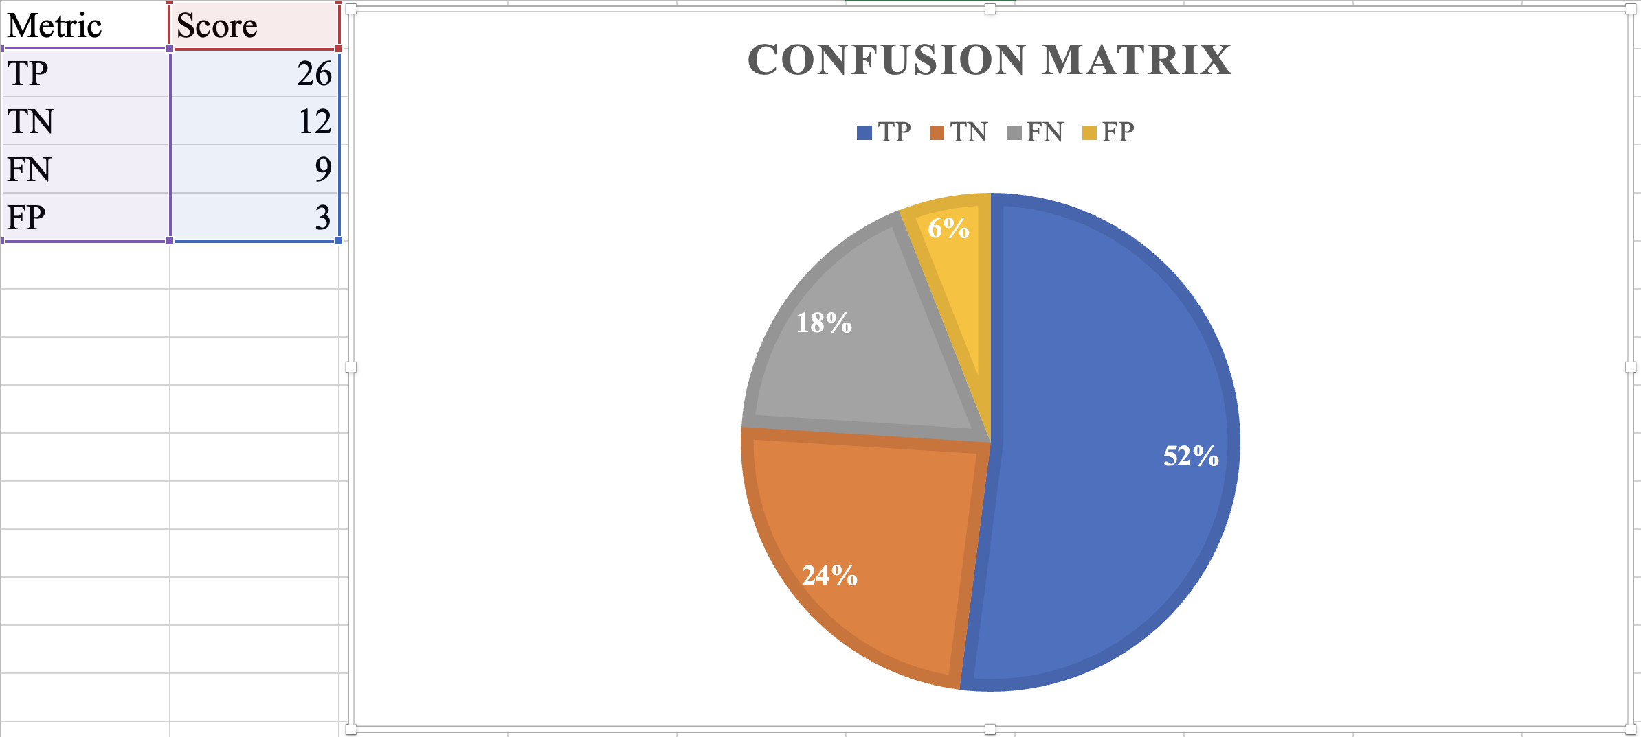

Fig. 13. Confusion Matrix

1. Conclusions and Future Work

Based on our observations and results obtained so far, we can conclude that the model takes less time (about 5 sec- when only final results are shown leaving unnecessary details) for processing an input image. The results are also quite decent giving almost 74% accuracy in detecting genuine currency and 80% accuracy in detecting counterfeit currency.

Currency use is a necessity for survival and hence it is always necessary to keep in track of its originality. Paper currencies are used much more in India and hence a system to detect the fake currency is needed. As the new currencies are used in the market, the proposed system seems to be useful to detect the currency to be genuine or not. This system compares more features for feature extraction than other proposed systems. It also shows where the differences are in the currencies instead of simply displaying the result. Our future work involves rigorous testing, improvement in computational efficiency and further incorporation of other security features to make it more robust and reliable so that it can be utilized in real time mobile phone applications. This system can be further implemented for foreign currencies like Dollars, Euros, Taka, etc. as a future scope.

REFERENCES

[1] P. Julia Grace, Ph.D., A. Sheema, —A survey on Fake Indian Paper Currency Identification System|| Grace et al., International Journal of Advanced Research in Computer Science and Software Engineering 6(7), July- 2016, pp. 340-345 ISSN: 2277 128X

[2] B. P. Yadav, C. Patil, R. Karhe, and P. Patil, “An automatic recognition of fake Indian paper currency notes using MATLAB,” Int. J. Eng. Sci. Innov.

[3] Technol, vol. 3, pp. 560–566, 2014 Zarin and J. Uddin, “A hybrid fake banknote detection model using OCR, face recognition and through features,” in 2019 Cybersecurity and Cyberforensics Conference (CCC). IEEE, 2019, pp. 91–95

[4] S. Veling, M. J. P. Sawal, M. S. A. Bandekar, M. T. C. Patil, and

[5] L. Sawant, “Fake Indian currency recognition system by using MATLAB.”

[6] Vidhi Roy, Gangey Mishra, Rahul Mannadiar, Sushant Patil, —Fake Currency Detection Using Image Processing|| International Journal of Computer Science and Mobile Computing April- 2016,

[7] S. Veling, M. J. P. Sawal, M. S. A. Bandekar, M. T. C. Patil, and L. Sawant, “Fake Indian currency recognition system by using MATLAB.”

[8] Singh, A. Choudhary, and V. Kumar, "Currency Authentication System Using Optical and Security Thread Features," Journal of Information Technology and Software Engineering 7(3), 2017, pp. 1-6.

[9] Reddy, S. Das, and T. Bhattacharya, "Machine Learning-Based Approach for Counterfeit Currency Detection," 2021 5th International Conference on Trends in Electronics and Informatics (ICOEI), IEEE, 2021, pp. 456-460.

[10] S. Mishra, A. Tiwari, and R. Dubey, "Fake Indian Currency Detection Using CNN and SVM," International Journal of Innovative Technology and Exploring Engineering 9(3), 2020, pp. 2278-3075.

[11] Sharma, P. Garg, and N. Kapoor, "A Comparative Study of Feature Extraction Techniques for Fake Currency Detection," International Journal of Engineering and Advanced Technology 8(6), 2019, pp. 2249-8958.

[12] Roy, B. Sen, and C. Banerjee, "Real-Time Fake Currency Identification Using IoT and Image Processing," 2022 IEEE International Conference on Consumer Electronics (ICCE), IEEE, 2022, pp. 1-5.

[13] V. K. Singh, R. Pandey, and S. Choudhary, "A Robust Framework for Detecting Counterfeit Banknotes Using Deep Neural Networks," Journal of Artificial Intelligence and Systems 2(1), 2021, pp.